Assembly and
Operation of the


Software Defined Radio Module
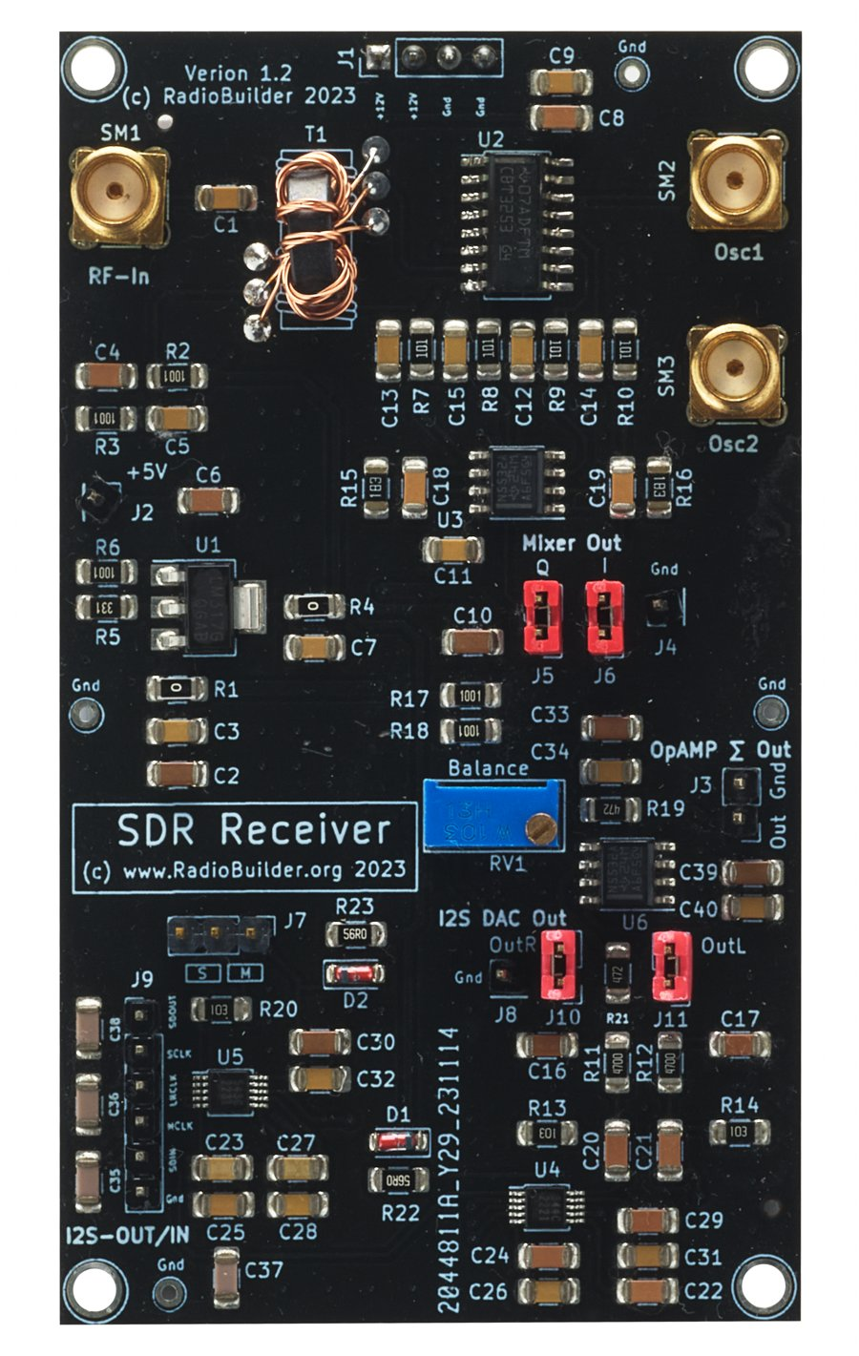
Component of the RadioLab
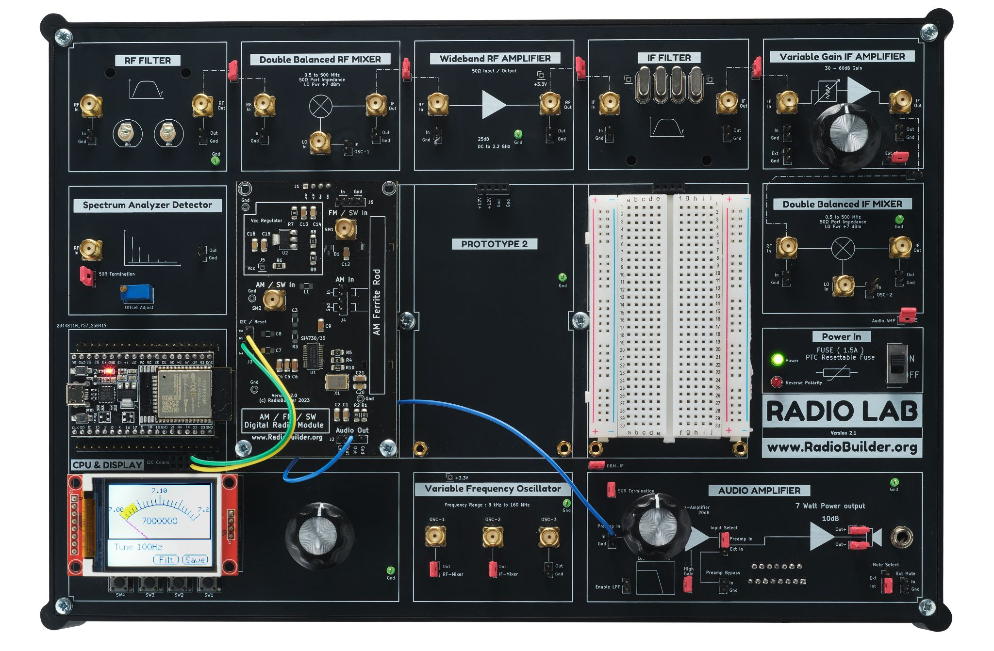

Contents
1.0 Software Defined Radio Overview 3
1.1 SDR Module Specifications 3
2.0 SDR Theory 4
2.1 Theory of Operation 4
2.2 Connection Diagram 5
2.3 Antenna 6
2.4 Jumper Configuration 6
2.5 Operation 6
3.0 Schematic Diagram 7
4.0 Circuit Description 8
4.1 Power Supply (U1) 8
4.2 RF Input and Splitter (T1) 8
4.3 Quadrature Sampling Detector (U2) 8
4.4 I and Q Amplifiers (U3) 8
4.5 A/D Converter (U5) 9
4.6 D/A Converter and Output Filter (U4) 9
4.7 Summing Amplifier and Balance (U6) 9
5.0 Embedded Software 10
6.0 Signal Tracking 11
6.1 DC Test Point Voltages 11
6.2 AC Signal Tracking 11
7.0 Experiments 12
7.1 Observing I and Q 12
7.2 Opposite Sideband Rejection 12
7.3 Changing Sideband 12
7.4 SSB and CW Filters 12
7.5 PC SDR Software 12
8.0 Videos 13
9.0 Assembly 14
9.1 Step 1 - Wind the Toroid (T1) 14
9.2 Step 2 - Power Header 15
9.3 Step 3 - Ground Test Points 15
9.4 Step 4 - Complete Assembly 16

1.0 Software Defined Radio Overview
A software defined radio (SDR) does in software much of the work that a conventional receiver does with coils, crystal filters and detectors. The RadioLab SDR Module converts the incoming RF signal directly to two audio-frequency signals, I (in-phase) and Q (quadrature, shifted 90°). The ESP32 then processes these digitally to select one sideband and filter the audio.
The mixer is a quadrature sampling detector, often called a Tayloe detector after Dan Tayloe, N7VE. It is the same circuit used in many popular amateur SDR receivers. It uses a low-cost analogue switch, has low loss, and gives good strong-signal performance.

1.1 SDR Module Specifications
Parameter | Typical Value
Receiver type | Direct conversion (zero-IF), I/Q
Mixer | Quadrature sampling detector, SN74CBT3253 (U2)
Local oscillator | Si5351 on the VFO module, OSC-1 (0°) and OSC-2 (90°)
Band (supplied sketch) | 40 m, 7.000 – 7.300 MHz
Modes | SSB (single sideband), CW
Detector bandwidth | ≈ 3.4 kHz
I/Q amplifier gain | 45 dB (×180)
A/D converter | CS5343, 24-bit, 98 dB dynamic range
D/A converter | CS4344, 24-bit, 105 dB dynamic range
Sample rate / resolution | 44.1 kHz, 16-bit (set by sketch)
DSP | ESP32, ±45° FIR (Hilbert) filters: 161 taps SSB, 261 taps CW
RF input | SM1 (SMA), 50 Ω
Audio output | Line level, J3
Supply | +12 V on J1, +5 V on-board regulator

2.0 SDR Theory
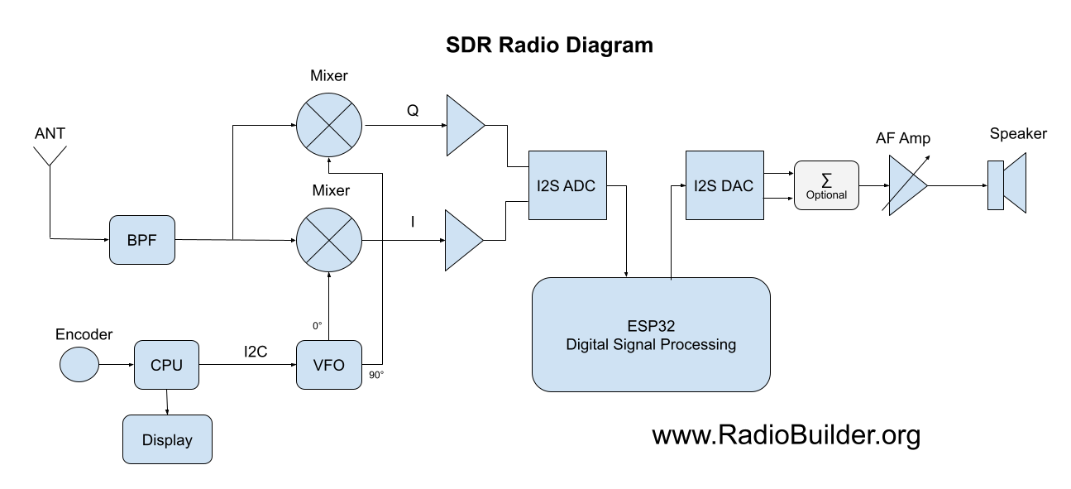
Block Diagram

2.1 Theory of Operation
The antenna signal passes through a band-pass filter and into two mixers. Both mixers are driven by the VFO at the receive frequency. The Q mixer's oscillator is shifted by 90°. Because the oscillator is on the receive frequency, each mixer output is audio: a station 1 kHz away from the VFO frequency comes out as a 1 kHz tone.
A single mixer cannot tell whether a station is 1 kHz above or 1 kHz below the VFO. Both give the same 1 kHz tone, so both sidebands are heard at once. The second mixer solves this. Its 90° oscillator makes the Q output lead or lag the I output by 90°, depending on which side of the VFO the signal is.
The I and Q signals are amplified and converted to digital by a stereo I²S A/D converter. The ESP32 shifts the I channel by +45° and the Q channel by −45° with FIR (Hilbert) filters, and sends both channels back out through an I²S D/A converter.
When the two channels are added, signals on the wanted side of the VFO add together and signals on the other side cancel. This is the phasing method of sideband selection. The sum is done on the module by the op-amp summing amplifier (U6), and the Balance control (RV1) matches the two channels for the best cancellation.
This module performs the mixers, I/Q amplifiers, A/D and D/A converters and summing amplifier shown in the block diagram. The band-pass filter, VFO, CPU, display and audio amplifier are other RadioLab modules.

2.2 Connection Diagram
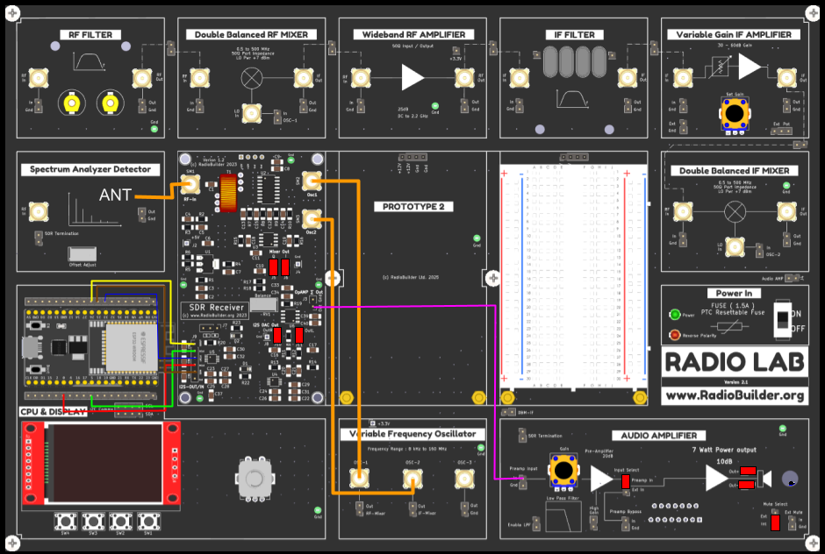
Connection Diagram
- RF-In (SM1) – antenna.
- Osc1 (SM2) – OSC-1 on the Variable Frequency Oscillator.
- Osc2 (SM3) – OSC-2 on the Variable Frequency Oscillator.
- OpAMP Σ Out (J3) – Out to the Preamp Input of the Audio Amplifier.
- I2S-OUT/IN (J9) – to the ESP32 on the CPU & Display board, see table below.

I²S Interface Connections (J9)
J9 Pin | Signal | Connect To | Function
1 | SDOUT | ESP32 GPIO26 | I/Q data from ADC (U5)
2 | SCLK | ESP32 GPIO5 | Bit clock
3 | LRCK | ESP32 GPIO33 | Left/right (word) clock
4 | MCLK | ESP32 GPIO0 | Master clock
5 | SDIN | ESP32 GPIO25 | Audio data to DAC (U4)

Gnd (J9 pin 6) is not required. Ground is connected through the supply header J1.

2.3 Antenna
Connect a 40 m antenna to SM1. A resonant dipole or end-fed wire gives the best results. A random wire of 10 – 20 m will receive strong stations. For the best selectivity, pass the antenna through the RF Filter module first. Disconnect outdoor antennas during thunderstorms.

2.4 Jumper Configuration
Jumper | Label | Setting | Function
J5 | Mixer Out Q | Fitted | Q amplifier to ADC left input
J6 | Mixer Out I | Fitted | I amplifier to ADC right input
J10 | I2S DAC Out R | Fitted | DAC right output to summing amplifier
J11 | I2S DAC Out L | Fitted | DAC left output to summing amplifier
J7 | S / M | Not Fitted | ADC clock mode: S = slave, M = master

The ESP32 is the I²S clock master and supplies MCLK, SCLK and LRCK, so J7 must be set to S. Remove J5/J6 to measure the I and Q signals on their own, or J10/J11 to hear a single DAC channel.

2.5 Operation
- Download the SDR_Reciever sketch to the board.
- Fit J5, J6, J10 and J11. Set J7 to S.
- Connect the antenna, the two oscillator cables, J9 and J3 as shown in the connection diagram.
- Switch on. The radio starts on the last saved frequency, or 7.000 MHz.
- Turn the encoder to tune. The meter shows 7.00 – 7.20 MHz.
- Press the encoder to change the tuning step: 10 Hz, 100 Hz, 1 kHz, 10 kHz, 100 kHz, 1 MHz.
- Press SW3 (Filt) to change between the SSB and CW filters.
- Press SW4 (Save) to store the current frequency.
- Tune a steady carrier on the unwanted sideband and adjust RV1 (Balance) for minimum signal.

Changing sideband – Swap the Osc1 and Osc2 cables, or swap the +45° and −45° filter coefficients in setup() of the sketch.

3.0 Schematic Diagram
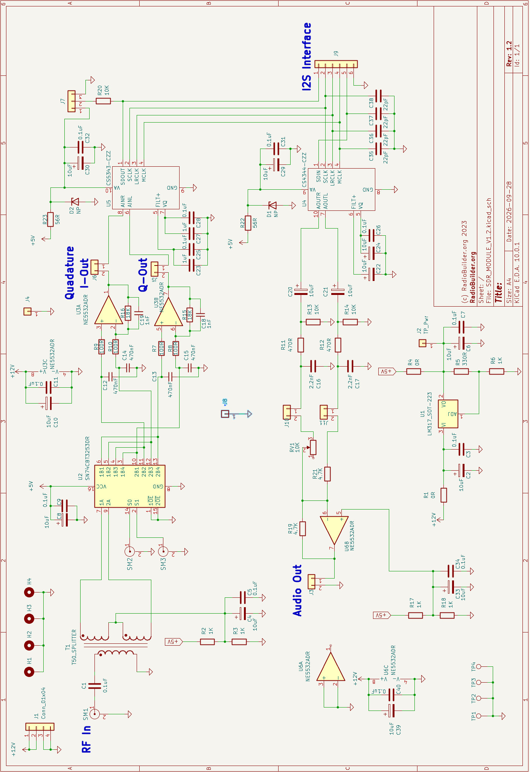
SDR Module Schematic

4.0 Circuit Description

4.1 Power Supply (U1)
The module takes +12 V from J1. The NE5532 op-amps (U3, U6) run directly from +12 V. An LM317 regulator (U1) produces +5 V for the mixer, the bias networks and the converters. The output voltage is set by R5 and R6:
Vout = 1.25 V × (1 + R6 / R5)
Vout = 1.25 V × (1 + 1000 / 330) = 5.04 V
- C2, C3 (10 µF, 0.1 µF) – input decoupling.
- C6, C7 (10 µF, 0.1 µF) – output decoupling.
- R1 (0 Ω) – input link.
- R4 (0 Ω) – output link to the +5 V rail.
- J2 (TP_Pwr) – +5 V test point.

4.2 RF Input and Splitter (T1)
The antenna signal enters at SM1 and is coupled by C1 (0.1 µF) into T1, a trifilar transformer of 8 turns on an FT-37-43 ferrite toroid. T1 splits the signal into two outputs 180° apart, which feed the two inputs of the mixer (U2 pins 7 and 9).
The centre tap of T1 is biased at 2.5 V by R2 and R3 (1 kΩ each from +5 V), decoupled by C4 and C5. This keeps the RF signal inside the supply range of the switch and sets the DC level for the op-amps that follow.

4.3 Quadrature Sampling Detector (U2)
U2 (SN74CBT3253) is a dual 4-way analogue switch. Its select inputs S0 and S1 are driven by the two oscillator signals on SM2 (Osc1) and SM3 (Osc2), which are at the receive frequency and 90° apart. Together they step the switch through four positions in every RF cycle, one position per quarter cycle.
Each switch position connects the RF signal to one of four sampling capacitors (C12 – C15, 470 nF) for a quarter of each cycle. Each capacitor charges to the average RF voltage during its quarter cycle. The four capacitor voltages are audio signals at 0°, 90°, 180° and 270°. The 0°/180° pair gives I and the 90°/270° pair gives Q.
The sampling capacitors and the antenna resistance also form a low-pass filter. Its bandwidth is approximately:
Bandwidth ≈ 1 / (π × 4 × R × C)
Bandwidth ≈ 1 / (π × 4 × 50 Ω × 470 nF) ≈ 3.4 kHz
This bandwidth is set before any amplification, so strong signals more than a few kHz away are attenuated before they reach the op-amps.

4.4 I and Q Amplifiers (U3)
U3A (I) and U3B (Q) are NE5532 low-noise op-amps. Each amplifies the difference between a pair of sampling capacitors: C12/C14 for I, C13/C15 for Q. The gain is set by the feedback resistor and the input resistors:
Gain = R16 / R9 = 18 kΩ / 100 Ω = 180 (45 dB)
C19 and C18 (1 nF) across the feedback resistors roll off the response above 1 / (2π × 18 kΩ × 1 nF) = 8.8 kHz. The outputs are I-Out (J6) and Q-Out (J5). C10 and C11 decouple the +12 V supply.

4.5 A/D Converter (U5)
U5 (CS5343) is a 24-bit stereo audio A/D converter. The I signal goes to AINR and the Q signal to AINL. The converter has its own anti-alias filter and a high-pass filter that removes the 2.5 V DC level. Its full-scale input is 0.568 × VA peak-to-peak.
R23 (56 Ω), D2, C30 and C32 supply and decouple VA. C23, C25, C27, C28 decouple the FILT+ and VQ reference pins.
J7 selects master or slave clock mode through R20 (10 kΩ) on SDOUT. Pulled up (M), the ADC generates the I²S clocks. Pulled down (S), it takes them from the ESP32.

4.6 D/A Converter and Output Filter (U4)
U4 (CS4344) is a 24-bit stereo audio D/A converter. It receives the processed audio from the ESP32 on SDIN and shares MCLK, SCLK and LRCK with the ADC. R22 (56 Ω), D1, C29 and C31 supply and decouple VA. C22, C24, C26 decouple FILT+ and VQ.
The outputs AOUTR and AOUTL are AC-coupled by C20 and C21 (10 µF) and loaded by R13 and R14 (10 kΩ). R11/C16 and R12/C17 (470 Ω, 2.2 nF) remove DAC switching noise above 1 / (2π × 470 Ω × 2.2 nF) = 154 kHz. The filtered outputs go to J10 and J11.
C35 – C38 (22 pF) on the I²S lines slow the clock edges and reduce interference.

4.7 Summing Amplifier and Balance (U6)
U6B is an inverting summing amplifier. The left DAC channel enters through R21 (4.7 kΩ) and the right channel through RV1 (Balance, 10 kΩ). R19 (4.7 kΩ) is the feedback resistor, so the left channel has a gain of 1. RV1 adjusts the right channel gain to match it.
The non-inverting input is biased at 2.5 V by R17 and R18 (1 kΩ each), decoupled by C33 and C34. The output is available at J3 (OpAMP Σ Out). U6A is not used and its inputs are tied to ground. C39 and C40 decouple the +12 V supply.

5.0 Embedded Software
The SDR_Reciever sketch runs on the ESP32 on the CPU & Display board. It uses the Arduino IDE with the ESP32 board package (board: ESP32 Dev Module).
Required libraries
- arduino-audio-tools (pschatzmann) – I²S input/output and FIR filtering.
- Etherkit Si5351 – VFO.
- TFT_eSPI and TFT_eWidget (Bodmer) – display and analogue meter.
- AiEsp32RotaryEncoder – tuning encoder.
- EasyButton – push buttons.

ESP32 pin assignments
Function | ESP32 GPIO
I²S WS / BCK / MCLK | 33 / 5 / 0
I²S data out (to DAC) / in (from ADC) | 25 / 26
Encoder A / B / push | 34 / 35 / 32
SW2 / SW3 / SW4 | 4 / 16 / 19

Signal processing – The sketch reads stereo I/Q samples from the ADC at 44.1 kHz, passes the I channel through a +45° FIR filter and the Q channel through a −45° FIR filter, and writes both channels to the DAC. The filter coefficients are in coeff.h. The SSB filters have 161 taps and the CW filters 261 taps. SW3 selects between them.
VFO – The Si5351 outputs CLK0 and CLK1 at the receive frequency. CLK1 is shifted 90° using the Si5351 phase register. The sketch chooses an even output divider for each frequency range and resets the PLL when the divider changes.
Saved frequency – SW4 writes the frequency to ESP32 flash. At start-up a saved frequency outside 7.000 – 7.300 MHz is replaced with 7.000 MHz.

6.0 Signal Tracking

6.1 DC Test Point Voltages
Test Point | Expected | Notes
J1 pin 1 | +12 V | Supply from the base board
J2 (TP_Pwr) | 5.04 V (4.85 – 5.20 V) | LM317 output
T1 centre tap | 2.5 V | R2/R3 bias
J5, J6 | 2.5 V | I and Q amplifier outputs
U6 pin 5 | 2.5 V | Summing amplifier bias
J3 Out | 2.5 V | DC level on audio output

6.2 AC Signal Tracking
- SM2, SM3 – square waves at the receive frequency, 90° apart. Check with a two-channel scope.
- J5, J6 – with a steady carrier 1 kHz from the VFO frequency, I and Q are 1 kHz sine waves 90° apart.
- J10, J11 – DAC outputs, both channels at similar level.
- J3 – summed audio. The unwanted sideband is reduced after RV1 is adjusted.

7.0 Experiments

7.1 Observing I and Q
Connect J6 (I) and J5 (Q) to a two-channel scope. Tune 1 kHz above a steady carrier and note which channel leads. Tune 1 kHz below the carrier: the other channel now leads. In X-Y mode the display is a circle, and its direction of rotation reverses as you tune through the carrier. This is how the receiver tells one sideband from the other.

7.2 Opposite Sideband Rejection
Tune a steady carrier into the unwanted sideband and adjust RV1 for minimum audio. Then remove J10 or J11. With only one channel reaching the summing amplifier there is no cancellation, and both sidebands are heard.

7.3 Changing Sideband
Swap the Osc1 and Osc2 cables. The 90° phase shift changes sign and the receiver now hears the other sideband. Compare with swapping the +45° and −45° filters in the sketch.

7.4 SSB and CW Filters
Tune a CW signal and press SW3 to change between the SSB (161 taps) and CW (261 taps) filters. Compare the noise and the interference from nearby signals.

7.5 PC SDR Software
Remove J5 and J6 and connect I-Out and Q-Out to the right and left line inputs of a PC sound card through 10 µF capacitors, with ground to J4. Use PC SDR software such as HDSDR to display a waterfall of the band around the VFO frequency.

8.0 Videos
The following videos by EI8KI cover the theory, filter design and testing of this module.
Video | Link
IQ SDR Understanding Without The Math | https://www.youtube.com/watch?v=2N5izgyWI-s
Hilbert Filter Design from scratch using Python and Iowa Hills software | https://www.youtube.com/watch?v=25dAzxzMPJ0
SDR Module Test and Debug Part 1 | https://www.youtube.com/watch?v=ikWBrKTEqFk
SDR Module Test and Debug Part 2 | https://www.youtube.com/watch?v=RjPIf9Wwwpk

9.0 Assembly
The surface mount parts are fitted. To complete the module, wind and fit the toroid T1, fit the power header J1 and fit the three ground test points.
Part | Qty
FT-37-43 Ferrite Toroid | 1
Enamelled Wire, 175 mm (7 in) | 3
4 Pin Header | 1
Ground Test Point | 3

9.1 Step 1 - Wind the Toroid (T1)
T1 is a trifilar winding: three wires wound on the toroid together, so the three windings have the same number of turns and are closely coupled.
- Cut three 175 mm (7 in) lengths of enamelled wire.
- Lay the three wires side by side and twist them lightly together. Twist only enough to keep them together.
- Pass the bundle through the centre of the toroid. Each pass through the centre is one turn.
- Wind 8 turns, always in the same direction, with even tension.
- Spread the turns evenly around the toroid. Do not stack turns on top of each other.

Lead identification – There are six leads, two for each wire. The three leads at the start of the winding are the A ends and the three at the finish are the B ends.
Wire | Start (A) | Finish (B)
Wire 1 | C1A | C1B
Wire 2 | C2A | C2B
Wire 3 | C3A | C3B

- Scrape or burn the enamel off the end of each lead and tin it.
- Solder each lead into the matching PCB pad. C1A is the ground pad.
- Check that no bare wire can touch another lead.
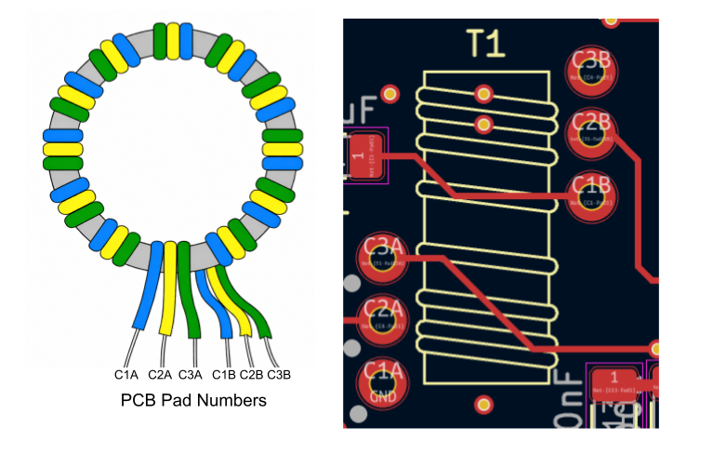
T1 Winding and PCB Pad Numbers

9.2 Step 2 - Power Header
Insert and solder the 4 pin header on the underside of the board in J1.

9.3 Step 3 - Ground Test Points
Insert and solder the three ground test points in the pads marked Gnd.

9.4 Step 4 - Complete Assembly
Completed SDR Module

